Industrial Training
On
Zero-Resource AI: Building Intelligent Systems in Data-Scarce Languages and Domains

- ACKNOWLEDGEMENT

I would like to express my sincere gratitude to all those who contributed to the successful completion of my industrial training and this project. This experience has been immensely valuable, and it would not have been possible without the support and guidance of several key individuals.
First and foremost, I extend my deepest appreciation to my guide Dr. Rajesh Mahadeva, Associate Professor in the School of Computer Engineering. His invaluable mentorship, consistent support, and expert encouragement throughout the training period were instrumental in achieving the desired project outcomes. His insightful feedback and profound expertise significantly shaped this work, and I am deeply grateful for the opportunity to have learned under his supervision.
I also wish to acknowledge the support and cooperation of my team members,Prarthana bk and Mohammed Wasif. There dedication, collaborative spirit, and shared commitment were essential in navigating the challenges we encountered and in successfully reaching our project goals.
A special thanks is due to the Department of Computer Science & Engineering and Manipal Institute of Technology for providing the necessary resources, state-of-the-art infrastructure, and a conducive academic environment for carrying out this project. The institution's commitment to fostering innovation has been crucial in bringing this project to fruition.
Finally, I extend my heartfelt gratitude to my family and friends for their unwavering support, patience, and encouragement throughout the course of this training. Their belief in me has been a constant source of motivation. Thank you all for your invaluable assistance and support.

- ABSTRACT

This industrial training project was carried out with the objective of designing a system that extracts written content from images and provides translations in the user’s preferred language. The tool makes use of the Tesseract OCR engine to detect and retrieve text from scanned images or documents, after which the No Language Left Behind (NLLB) model is applied to generate translations. The application supports a range of Indian as well as international languages, allowing flexibility in both input and output selection. By bringing together text recognition and translation in one platform, the project offers a practical approach for handling multilingual information.
The work highlights the importance of simplifying access to knowledge across different languages. Instead of manually retyping text or relying on multiple software tools, this application combines both processes into a single automated system. Such a solution is useful in various fields including education, workplace communication, and everyday situations where documents appear in unfamiliar languages. Through this project, the potential of combining OCR with machine translation is demonstrated, showing how technology can assist in improving understanding and bridging linguistic differences.

Table of Contents
CHAPTER | TITLE | PAGE NO.
1 | Acknowledgement | 4
2 | Abstract | 5
4 | Introduction | 9
Section 4.1 | Background and Motivation | 9
Section 4.2 | Problem Statement | 9 - 10
Section 4.3 | Problem Objectives | 10 - 11
Section 4.4 | Scope of the project | 11 - 12
Section 4.5 | Significance of the Project | 12 - 13
5 | Technology Stack | 14
Section 5.1 | OCR | 14
Section 5.2 | Machine Translation | 14
Section 5.3 | Supporting tool and libraries | 14
Section 5.4 | Environmental setup | 14
Section 5.5 | Security and Ethical Considerations | 15
Section 5.6 | Technology stack diagram | 15
6 | Functional Overview | 16
Section 6.1 | Features | 16
Section 6.2 | Limitations | 17
Section 6.3 | System Architecture | 17 – 18
Section 6.4 | Future Enhancement | 18
7 | Output | 19 - 22
8 | Conclusion | 23

INTRODUCTION

4.1 BACKGROUND AND MOTIVATION
With the growing reliance on digital technologies, the ability to process information across multiple languages has become an essential requirement. In a multilingual environment such as India, documents and resources often appear in diverse regional scripts, which limits accessibility when confined to a single language. To address this challenge, artificial intelligence techniques such as optical character recognition (OCR) and machine translation provide an effective way of extracting meaningful information and making it available to a wider audience. Such tools not only improve inclusivity but also support smoother communication, education, and professional collaboration.
The motivation for this project emerged from the need to integrate these two capabilities into a single framework. Using Tesseract OCR for text extraction and Meta’s NLLB (No Language Left Behind) model for multilingual translation, the system was designed to recognize text from images and convert it into accessible formats across different languages. By focusing on regional languages like Kannada, Hindi, Tamil, Marathi, and Gujarati, along with French as a foreign language, the project demonstrates how technology can bridge linguistic barriers and create opportunities for wider digital participation.

4.2 PROBLEM STATEMENT
In a multilingual country like India, where documents and resources are often created in diverse regional languages, the need for accurate text recognition and translation is becoming increasingly critical. Despite advances in digital tools, extracting text from images and converting it into a usable format across multiple languages remains a major challenge. This project addresses these challenges through the following focus areas:
- Reliable Text Extraction from Images: Printed and handwritten texts in regional scripts are often difficult to digitize accurately. Optical character recognition (OCR) systems must be able to handle variations in fonts, image clarity, and script complexity. This project focuses on using Tesseract OCR to extract text efficiently from images across different languages.
- Accurate Multilingual Translation: Once text is extracted, ensuring its accurate translation into another language is equally important. Many existing tools struggle with lesser-resourced languages such as Kannada, Tamil, or Marathi. By leveraging Meta’s NLLB (No Language Left Behind) model, the project aims to deliver precise translations across multiple Indian and foreign languages.
- Integration of OCR and Translation in a Single Framework: Most available solutions treat OCR and translation as separate processes, creating gaps in usability. This project seeks to combine these two steps into one streamlined workflow, making the system more practical and accessible for end users.
- Scalability and Usability: For such a system to be effective, it must work reliably across different contexts, languages, and use cases. Designing a framework that is adaptable, user-friendly, and capable of handling diverse input data is a central part of the problem being addressed.
These challenges highlight the importance of building an AI-based solution that not only bridges the gap between image-based text and multilingual accessibility but also contributes to making information more inclusive in today’s digital landscape.

  - PROJECT OBJECTIVES
The primary objective of this training was to design and implement a system that can extract text from images and translate it accurately across multiple languages using modern AI tools. The project was structured around the following specific goals:
- Implement Optical Character Recognition (OCR):
Use Tesseract OCR to identify and extract text from images in different scripts, ensuring reliable recognition even with variations in fonts, resolution, and formatting.
- Integrate Multilingual Translation:
Employ Meta’s NLLB (No Language Left Behind) model to translate extracted text into various target languages, with emphasis on Indian languages such as Kannada, Hindi, Tamil, Marathi, and Gujarati, along with French.
- Develop a Unified Workflow:
Combine the OCR and translation processes into a single streamlined framework, reducing the need for multiple tools and making the system user-friendly and practical.
- Ensure Scalability and Flexibility:
Design the framework so that it can be adapted to support additional languages and use cases in the future, ensuring that the system remains relevant and extendable.
- Focus on Accuracy and Reliability:
Address common challenges such as OCR misreads, translation errors, and script handling by testing and refining the system across diverse inputs to improve overall performance.
- Provide Practical Utility:
Create a tool that can be applied in academic, professional, and organizational contexts where multilingual communication is essential, thereby demonstrating the real-world value of the system.
These objectives collectively aimed to provide hands-on experience in artificial intelligence, natural language processing, and system integration. The training offered an opportunity to apply theoretical concepts in a practical setting while contributing to the development of tools that support linguistic inclusivity and digital accessibility.

  - SCOPE OF THE PROJECT
The project is centered on building a system that integrates text extraction from images with multilingual translation in a single workflow. The key components covered within the scope of this work include:
- Optical Character Recognition (OCR): Implementation of Tesseract OCR to extract text from images containing printed scripts in multiple languages.
- Multilingual Translation: Use of Meta’s NLLB model to translate recognized text into selected target languages, with focus on Indian regional scripts and French.
- System Integration: Development of a unified framework that connects OCR with translation, ensuring smooth processing from input image to translated text.
- Usability and Accessibility: Designing the workflow to be straightforward and adaptable, so that it can be used by individuals with varying technical expertise.
- Performance Testing: Evaluation of the system’s accuracy and efficiency across different scripts, fonts, and image qualities to validate its reliability.
Out of Scope:
- Handwritten Text Recognition: The project is limited to printed text and does not extend to complex handwritten script recognition.
- Speech or Audio Translation: Conversion of spoken language into text or translation of audio content is outside the scope of this system.
- Cloud or Mobile Application Deployment: While the system demonstrates the process locally, it does not include deployment on mobile platforms or cloud-based services.

  - SIGNIFICANCE OF THE PROJECT
The work carried out in this project holds strong relevance in the domain of artificial intelligence and language technologies, particularly because it addresses the challenge of processing information across multiple languages. Its significance can be understood in the following aspects:
- Facilitating Multilingual Communication:
The system helps bridge linguistic differences by converting printed text from regional scripts into other languages. This has the potential to benefit students, professionals, and organizations that work in multilingual environments where language barriers often limit access to information.
- Enhancing Access to Information:
By enabling the recognition of text from images and converting it into readable, translated content, the project ensures that valuable data in documents, posters, or scanned copies does not remain restricted to a single audience. This directly contributes to improving accessibility and inclusivity in digital communication.
- Practical Demonstration of AI Tools:
The project shows how existing technologies like Tesseract OCR and Meta’s NLLB translation model can be combined to create a functional system. This practical application highlights the growing importance of AI in solving everyday problems related to documentation and language diversity.
- Room for Extension and Growth:
Although the current focus is on printed text, the framework lays the groundwork for possible future enhancements, such as support for handwritten documents, voice-based translation, or mobile deployment. This makes the project a stepping stone toward more advanced and versatile applications.
- Contribution to Digital Inclusivity:
At a broader level, the project underscores the role of AI in supporting inclusivity by making multilingual content more accessible. It demonstrates how technology can foster knowledge sharing and collaboration across different linguistic and cultural groups.
In conclusion, the project is valuable not only for its technical achievements but also for its social impact. It emphasizes how artificial intelligence can be applied in meaningful ways to support communication, accessibility, and inclusivity in a world shaped by linguistic diversity.

- TECHNOLOGY STACK

5.1 Optical Character Recognition (OCR)
- Tesseract OCR: Describe why you chose Tesseract (open-source, supports multiple languages, good for printed text).
- Pillow (PIL): Mention using Python’s PIL library to preprocess images (resizing, binarization, etc.) for better OCR accuracy.
5.2 Machine Translation
- Meta NLLB-200 Model: Explain that the No Language Left Behind model was used to translate extracted text into multiple languages (Kannada, Hindi, Tamil, Marathi, Gujarati, French, English).
- Hugging Face Transformers: Highlight how you used the transformers library for model loading, tokenization, and inference.
- PyTorch: Note that PyTorch served as the deep learning backend for running the NLLB model efficiently.
  - Supporting Tools and Libraries
- Python: Main programming language used to integrate OCR and translation.
- Argparse: For building a command-line interface to make the system interactive.
- Logging: To track errors, debug outputs, and maintain structured records during execution.
5.4 Environment Setup
- Local Execution: Mention that the system was first tested locally with models stored on disk.
- Offline/Online Model Handling: Explain how the program first checks for a local copy of the NLLB model, and if not found, downloads it via Hugging Face.
- Hardware/Software Requirements: (optional) You can briefly add info like Python 3.10+, CUDA/GPU support (if applicable).

5.5 Security and Ethical Considerations
- Emphasize handling of multilingual data responsibly.
- Mention that outputs are for educational/research use and respect intellectual property.

5.6 Technology Stack Diagram:

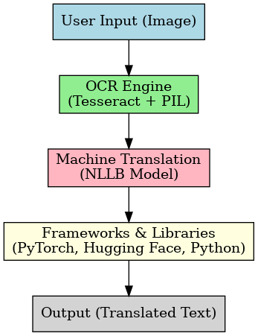

Figure: Technology stack of the project illustrating the integration of OCR (Tesseract and PIL), machine translation (NLLB), and supporting frameworks (PyTorch, Hugging Face, and Python) leading to the translated output.

- FUNCTIONAL OVERVIEW

6.1 FEATURES OF THE PROJECTS

- Multilingual Text Extraction
The system can read text from images in multiple Indian languages like Kannada, Hindi, Tamil, Marathi, and Gujarati, as well as international languages such as French.
- High-Quality AI Translation
Integrated with Meta’s NLLB model, it provides accurate translations between a wide range of languages, making communication across regions seamless.
- All-in-One Workflow
Text extraction and translation are combined into a single, smooth process, so users don’t need to juggle separate tools.
- Simple Command-Line Interface
Users can easily select source and target languages and process images without navigating a complicated interface.
- Works Fully Offline or Online
The tool can run entirely without an internet connection using pre-downloaded models. It also supports online downloads if needed.
- Enhanced OCR Accuracy with Image Preprocessing
Images are automatically resized and enhanced using Python’s imaging tools, improving recognition quality.
- Supports Local and Global Languages
Bridges the gap between regional Indian languages and widely spoken global languages, expanding usability.
- Transparent and Debug-Friendly
A built-in logging system tracks execution steps and errors, making the tool reliable and easier to debug.
- Expandable and Future-Ready
The framework is designed to accommodate new languages or advanced features, such as handwriting recognition or speech-to-text, in the future.
- Lightweight and Educational
Built as a training project, it demonstrates practical AI applications without requiring heavy infrastructure and can operate completely offline.
6.2 LIMITATIONS OF THE PROJECT
- Works Best with Clear Images
Poor-quality, blurry, or distorted images can reduce text extraction accuracy.
- Partial Language Coverage
Not all global or regional languages are supported yet, and uncommon dialects may not work.
- Model Constraints
Translation depends on the AI model; rare words or slang may sometimes be inaccurate.
- Performance on Large Inputs
Processing very large images or batches can be slow on computers with limited resources.
- Handwriting is Challenging
Currently optimized for printed text; handwritten content may not be recognized reliably.
- Basic Interface
The command-line interface is simple but may not be ideal for non-technical users.
6.3 SYSTEM ARCHITECTURE OF THE PROJECT
The system follows a step-by-step workflow to extract and translate text efficiently:
- Image Upload – The user provides the image containing the text.
- Image Enhancement – The image is automatically resized and adjusted for clarity using Python Imaging Library (PIL).
- Text Detection (OCR) – The enhanced image is scanned for text in the chosen source language.
- Translation Module – Detected text is sent to the AI model (NLLB) to convert it into the desired target language.
- Output Display – Translated text is shown on the screen or saved to a file.
- Logging – Every step, including errors and processing info, is recorded to help with debugging and tracking.
The architecture is flexible enough to run entirely offline with local models, but it can also fetch models online when necessary.

6.4 FUTURE ENCHANCEMENT OF THE PROJECT
- Handwriting Recognition – Expanding capabilities to read handwritten notes.
- Audio Input – Adding speech-to-text so audio can be transcribed and translated.
- User-Friendly Interface – Introducing a graphical interface for easier interaction.
- Real-Time Translation – Translating images or video frames instantly.
- More Language Options – Including additional regional and international languages.
- Smart Image Processing – Using AI to handle very poor-quality or complex images.

- OUTPUT:

7.1 Translated from Tamil to French

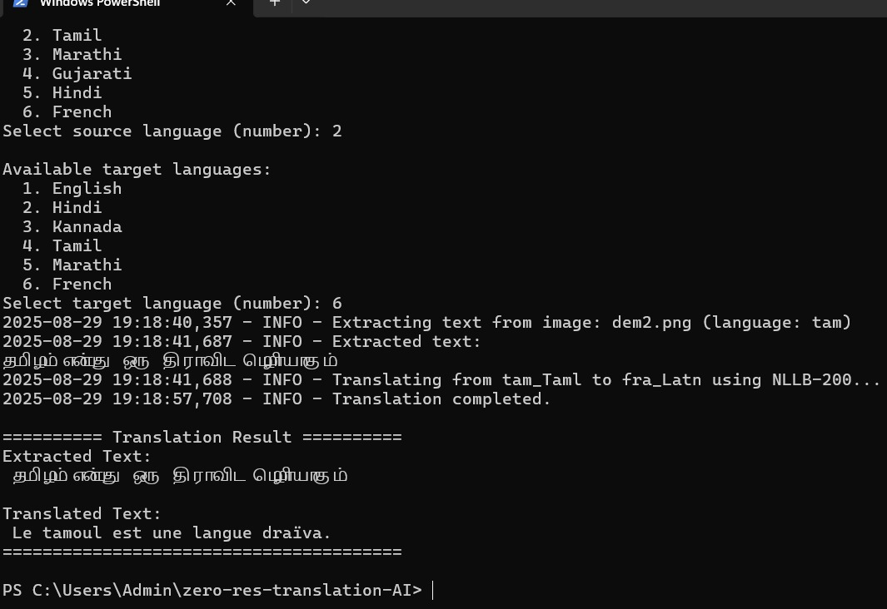

7.2 Translated from Gujarati to Kannada

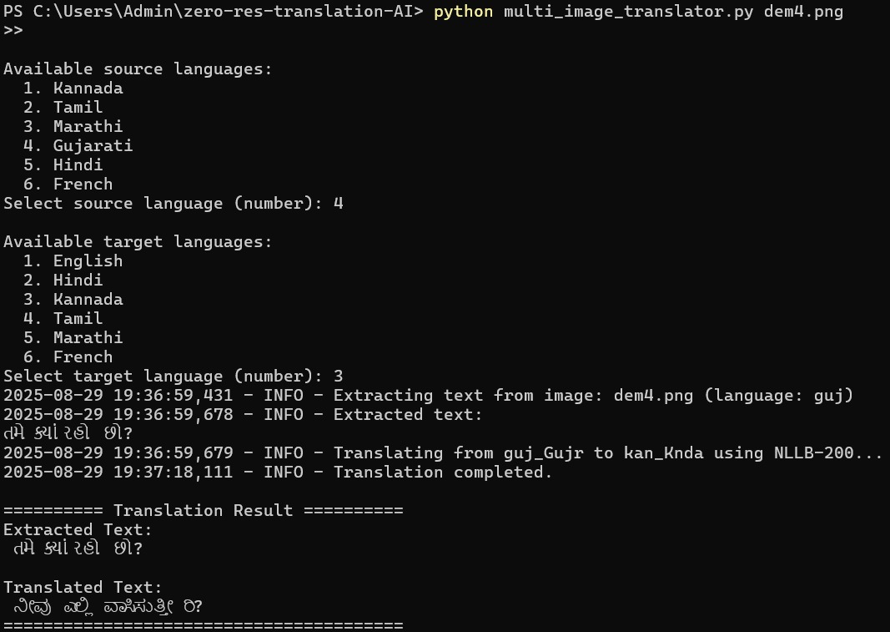

7.3 Translated from Marathi to English

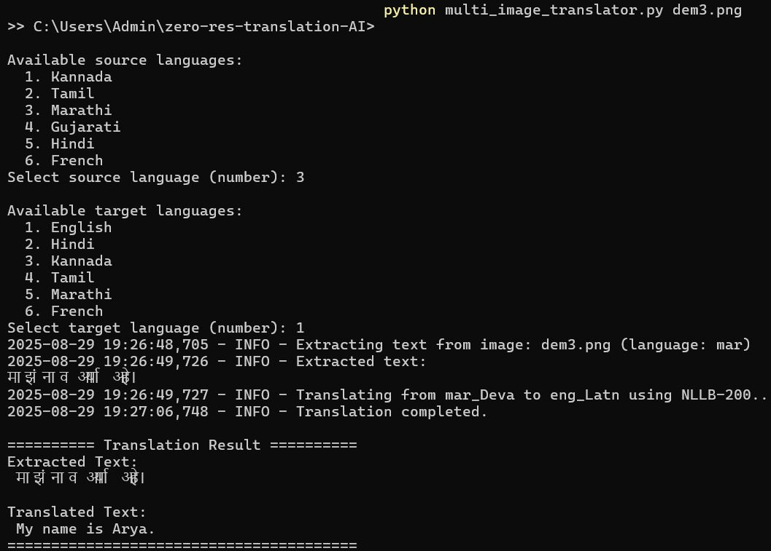

7.4 Translated from Kannada to Hindi

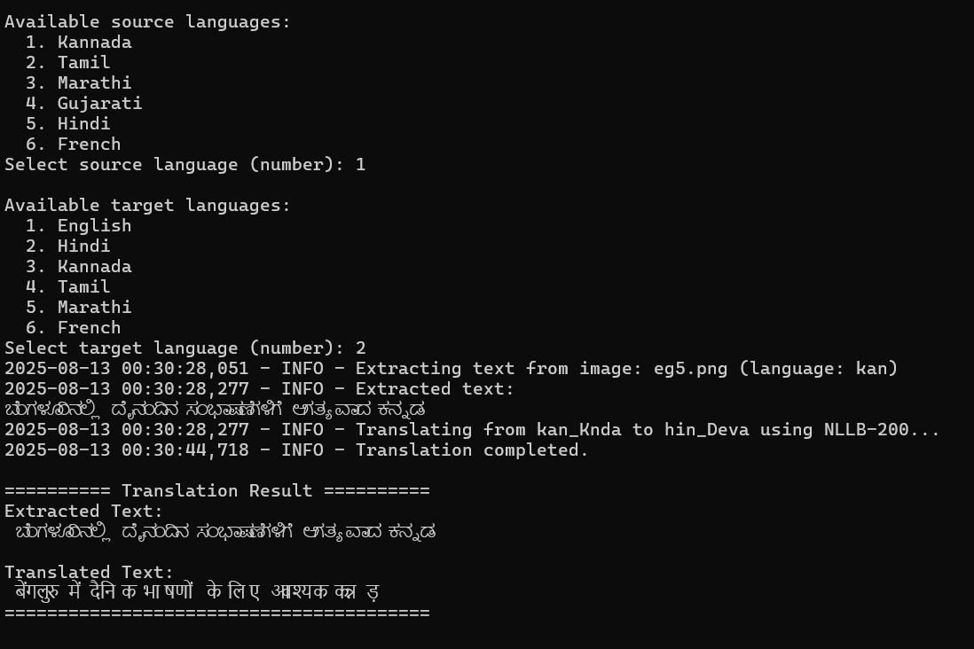

- CONCLUSION

The project successfully developed a system that combines text extraction from images with multilingual translation, offering a practical solution for bridging language barriers. By using Tesseract OCR for detecting text in various Indian languages and Meta’s NLLB model for translation, the system demonstrates how AI can make regional content more accessible to a global audience, including French-speaking users.
This work highlights the value of integrating multiple AI tools into a single workflow, ensuring both accuracy and efficiency. The preprocessing of images and careful handling of translation tasks contribute to reliable results while maintaining usability for non-technical users.
While the current implementation focuses on printed text and does not yet handle handwritten documents or real-time translation, it provides a strong foundation for future improvements, such as voice input, expanded language coverage, and enhanced user interfaces.
Overall, the project not only illustrates the practical application of modern AI techniques but also emphasizes the social impact of enabling multilingual communication. It serves as a step toward making digital information more inclusive, demonstrating how technology can overcome linguistic challenges and facilitate broader knowledge sharing.

REFERENCES
[1] N. C. Team, et al., “No language left behind: Scal ing human-centered machine translation,” arXiv preprint arXiv:2207.04672, 2022.
[2] O. Firat, K. Cho, and Y. Bengio, “Multi-way, multilingual neural machine translation with a shared attention mechanism,” arXiv preprint arXiv:1601.01073, 2016.
[3] S. Sarkar, P. Ghosal, and P. Goyal, “Printed OCR for extremely low-resource indic languages,” in Proc. International Confer ence on Natural Language Processing (ICON), 2022.
[4] C. Wang, P. Chanda, and V. Govindaraju, “Towards de ployable OCR models for indic languages,” arXiv preprint arXiv:2205.06740, 2022.
[5] R. Smith, “An overview of the Tesseract OCR engine,” in Proc. Ninth International Conference on Document Analysis and Recognition (ICDAR), 2007, vol. 2, pp. 629–633.
[6] T. Wolf, et al., “Transformers: State-of-the-art natural language processing,” in Proc. EMNLP (System Demonstrations), 2020, pp. 38–45.
[7] A. Paszke, et al., “PyTorch: An imperative style, high performance deep learning library,” in Advances in Neural Information Processing Systems 32, 2019, pp. 8024–8035.
[8] K. Mundnich, et al., “Zero-resource speech translation and recognition with LLMs,” in Proc. IEEE International Confer ence on Acoustics, Speech and Signal Processing (ICASSP), in press.
[9] G. van Rossum and F. L. Drake Jr, Python 3 Reference Manual. Scotts Valley, CA: CreateSpace, 2009.
[10] Meta AI, “facebook/nllb-200-distilled-600M,” Hugging Face, 2022. [Online]. Available: https://huggingface.co/facebook/ nllb-200-distilled-600M
[11] A. Clark, et al., “Pillow (PIL Fork),” Python Package Index, 2023. [Online]. Available: https://pypi.org/project/Pillow/
[12] M. Lee, “pytesseract,” Python Package Index, 2021. [Online]. Available:
[13] A. Conneau et al., “Unsupervised cross-lingual representation learning at scale,” arXiv preprint arXiv:1911.02116, 2019.
[14] X. N. Han, Z. X. Zhang, and N. L. V. Dao, “IndicTrans: A massively parallel corpus for Indic language translation,” in Proc. EMNLP, 2021.
[15] P. Goyal, “The IIT Bombay English-Hindi parallel corpus,” in Proc. LREC, 2018.
[16] M.Jaderberg, K. Simonyan, A. Zisserman, and K. Kavukcuoglu, “Spatial transformer networks,” in Advances in Neural Informa tion Processing Systems 28, 2015, pp. 2017–2025.
[17] Y. Liu et al., “RoBERTa: A robustly optimized BERT pretrain ing approach,” arXiv preprint arXiv:1907.11692, 2019. https://pypi.org/project/pytesseract

PLAGIARISM REPORT

